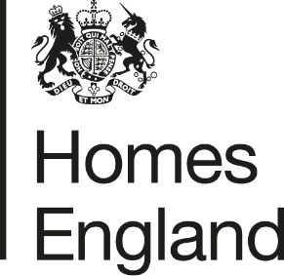
Making homes happen

CITY DEAL EXECUTIVE & STEWARDSHIP BOARD 6th October 2020
Homes England Quarterly Monitoring Progress Update Report
Quarter 1 2020 / 21
- Report Overview
  - This report provides an update on the progress that has been made in relation to the Homes England sites that form part of the Preston, South Ribble and Lancashire City Deal. The update relates to the progress that has been made during the first quarter of the 2020 / 21 financial year, between 1st April and 30th June 2020.
  - The report focuses on key delivery milestones, finances invested, and outputs generated, and provides a breakdown of the key risks and any emerging issues across the portfolio of sites.
- Recommendation
  - Homes England recommends that the Executive and Stewardship Board:
Note the content of this report and the progress made by Homes England during the first quarter of 2020 / 21.
- Homes England Site Highlights
  - As indicated in the previous quarterly update at the end of the 2019 / 20 financial year; the global pandemic ‘Covid-19’ has impacted the delivery of development across all of the Homes England City Deal sites, with all developer’s ceasing operations for a period of time during ‘lockdown’ in the first quarter of the 2020 / 21 financial year.
  - We anticipate that the impacts of the pandemic on the housing market, and the on-going delivery of City Deal sites will continue to be realised throughout 2020 / 21. Homes England will include an update on these matters in future monitoring reports.
  - Key highlights from the first quarter of 2020 / 21 are set out in the table below:
Phase / Plot | Status | Completions/  Total Units | Completions  (April – June) | Finance  (April – June) | Summary
1. Cottam Hall
Phase 1 | Phase completed by Barratt Homes | 104 / 104 (100%) | n/a | n/a | n/a - Build out complete
Phase 2 | Story Homes on-site | 123 / 283 (43%) | 0 | n/a | No completions this quarter due to developer being out of action during lockdown
Phase 3 | Morris Homes on-site | 3 / 119  (3%) | 3 | n/a | Start on site made Q4 2019/20, but delivery affected by lockdown. First 3 completions achieved June 2020.
Phase 4 | Conditional deal agreed with Rowland Homes. Reserved matters approved July 2019 | 0 / 141  (0%) | n/a | n/a | Reserved Matters Application for 141 homes was approved on 11th July 2019. Modification to GCN licence has been approved. Homes England has concluded S106 agreement discussions with third parties. It is anticipated that the unconditional stage of the deal will complete and housebuilding to commence Q3 2020 / 21
Phase 5 | Site not yet released for disposal | 0 / 233  (0%) | n/a | n/a | Tender to appoint preferred developer partner likely to be advertised post-lockdown, Summer 2020.
Phase 6  (Plots 14 and 15) | Both plots (14 and 15) disposed of on an unconditional and conditional basis to Countryside and Barratt Homes respectively. | 0 / 189  (0%) | n/a | n/a | Plot 14: Countryside on-site, but out of action during lockdown. First completions estimated Q3 2020.  Plot 15: Disposed of on a conditional basis to Barratt Homes in March Q4 2019/20. No reserved matters application has been submitted yet. A Reserved Matters planning pack is expected to be received beginning of Q3 2020.
Local Centre | Disposal of site for Local Centre anticipated Q3 2020 | n/a | n/a | n/a | Homes England continues to negotiate deal with Thistlewood Properties. Anticipated completion Q3 2020.
2. Cottam Brickworks
Access agreement | Ongoing discussion regarding access into adjacent land via Homes England site | 0 / 260  (0%) | n/a | n/a | Discussion ongoing to find a resolution to the site’s access rights. Homes England monitoring the ongoing dialogue between landowner and LCC.
3. Land at Eastway
Residential Plot | Story Homes on-site completing build out | 110 / 329  (33%) | 0 | n/a | Story Homes continues to build out site, however developer out of action during lockdown leading to no completions this quarter.
Commercial Plot | Site under conditional contract with HSB Healthcare | n/a | n/a | n/a | Homes England acquired community registered asset (CRA) land within the vicinity of the site in Q4 2019 / 20. Delivery of a new access into the site is anticipated Q2 2020 but start on site may be delayed due to Covid-19.
4. Whittingham Hospital
Phase 1 | Taylor Wimpey has completed Phase 1 | 150 / 150 (100%) | n/a | n/a | Taylor Wimpey has completed build out of Phase 1.
Phase 2 | Preferred bidder Barratt David Wilson selected end of March 2020. | 0 / 232  (0%) | n/a | n/a | Preferred bidder Barratt David Wilson selected at the end of March 2020 and conditional contract agreed. Reserved matters likely to be submitted Q3 2020.
Phases 3 and 4 | Not yet released. Disposal phases and options to be reviewed in 2020 / 21. | 0 / 512  (0%) | n/a | n/a | Current strategy is to dispose of part of the next phase (circa 40 units) sometime this financial year, however this is currently being considered, particularly the approach to drainage across both phases.
5. Preston East
Expansion Area | In Q4 2019 / 20 Homes England submitted a representation to the Central Lancashire Local Plan review supporting further allocation of the site. | n/a | n/a | n/a | Homes England submitted a Development Statement to promote the site for continued allocation within the Central Lancashire Local Plan.  The site is currently being marketed, with several offers already received this quarter. Marketing to close Q2 2020.
Sector D | Build-out of site complete. | n/a | n/a | n/a | Build-out of site complete.
6. Pickerings Farm
n/a | Masterplan and outline application submitted | 0 / 275  (0%) | n/a | n/a | Masterplan and outline application (ref. 07/2020/00015/ORM) currently being considered and detailed dialogue with SRBC and LCC is taking place. Masterplan to be presented at the planning committee Q2 2020.
7. Altcar Lane
n/a | Continued build-out of site by Lovell | 25 / 200  (13%) | 0 | n/a | No completions this quarter due to developer being out of action during lockdown.
8. Croston Road North
n/a | Keepmoat selected as preferred developer in October 2019 | 0 / 400  (0%) | n/a | n/a | Hybrid application including reserved matters for the 400 units anticipated to be submitted by Keepmoat in Q2 2020.
9. Croston Road South
Phase 1 | Miller Homes has completed Phase 1 | 96 / 96 (100%) | n/a | n/a | Miller Homes has completed build out of Phase 1
Phase 2 | Miller Homes on-site phase 2 | 68 / 79  (86%) | 0 | n/a | No completions this quarter due to developer being out of action during lockdown
10. Brindle Road
n/a | Complete | 46 / 46  (100%) | n/a | n/a | All units completed and all finances paid.
11. Walton Park Link
n/a | Morris on site | 17 / 275  (6%) | 0 | n/a | Morris commenced early site clearance works on site in September 2019. Remediation work and construction of link road, with first housing completions delivered.
- Finance
  - Homes England is currently still on track to pay the majority of £37.5 million grant by 2023 / 24 however this position has been reviewed as part of the Homes England Business Disposal Plans (BDP) Refresh (2020/21-2023/24). Some grant will now be paid up to 2030 in relation to the contract with Keepmoat at Croston Road North.
  - No grant or loan payments have been made during Q1 of the 2020 / 21 financial year.
  - The following payments are anticipated to be made over the coming financial year:
    - A loan amount of £123,497.00 is expected to be paid out in Q3 of 2020 (estimated September) in relation to the sale of the Local Centre site at Cottam Hall
    - A loan amount of £1,217,707.00 is currently anticipated to be paid out in Q3 of 2020 (estimated November) subject to reserved matters consent being achieved and agreement with Keepmoat going unconditional on Croston Road North
    - A loan amount of £2,578,006.00 is also expected to be paid out within the latter period of 2020/21 in relation to Phase 4 (Plots 1-3) of Cottam Hall and
    - Grant payments totalling c£3.5m are forecast to be paid in relation to development at the Eastway site later in 2020/21.
- Affordable Housing Provision
  - The following table provides a break-down of the on-site affordable homes provision made across Homes England’s City Deal sites:
City Deal Site |  | Total Units with Planning Consent |  | Total Units anticipated to be delivered across Homes England Land Only | Of which: Open Market Sales | Of which: Affordable / Social Rent | Of which: Percentage Affordable | Completions to date across Homes England Land Only | Affordable / Social Rent / Shared Ownership Completions
 |  | Granted | Awaited
1 | Cottam Hall | Up to 1,100 | - | 1,069 | 713 | 340 | 30% | 230 | 52
2 | Cottam Brickworks* | n/a | n/a | n/a | n/a | n/a | n/a | n/a | n/a
3 | Land at Eastway | 329 | - | 329 | 280 | 49 | 15% | 110 | 15
4 | Whittingham Hospital | 900 | - | 894 | 781 | 113 | 13% | 150 | 17
5 | Preston East EA | n/a | n/a | n/a | n/a | n/a | n/a | n/a | n/a
6 | Pickering’s Farm ** | - | 275 | 275 | TBC |  |  | 0 | 0
7 | Altcar Lane | 200 | - | 200 | 140 | 60 | 30% | 25 | 13
8 | Croston Road North | 400 | - | 400 | 340 | 60 | 15% | 0 | 0
9 | Croston Road South*** | 254 | - | 175 | 149 | 26 | 15% | 164 | 26
10 | Brindle Road | 46 | - | 46 | 46 | 0 | 0% | 46 | 0
11 | Walton Park Link* | n/a | n/a | n/a | n/a | n/a | n/a | n/a | n/a
Total |  | 3,229 | 275 | 3,388 | 2,449 | 664 | n/a | 725 | 123
* The landowner / developers at Cottam Brickworks and Walton Park Link are responsible for obtaining planning consent for the development proposed, not Homes England.
** The 275 units at Pickering’s Farm relate to the original Homes England land forming part of the original City Deal agreement. Following submission of the outline planning application, it is anticipated that 1,020 homes will be delivered overall: 745 by Taylor Wimpey and 275 by Homes England.
*** The 254 units shown comprises Phase 1 (175 units) completed by Miller Homes, and Phase 2 (79 units) currently under construction.
- Summary of Delivery
  - The impact of Covid-19 has been felt this quarter, with the build-out of many sites stalled due to developer’s ceasing operations during ‘lockdown’ with only 3 housing completions recorded.
  - That said, Morris Homes have successfully managed to achieve the completion of the first units to be built across Phase 3 at Cottam Hall by Morris Homes, whilst initial bids have been received in response to the marketing of the Preston East Expansion Area showing a strong interest in the site.
  - It should also be noted that several contract variations have been sought in response to the pandemic this quarter, for example at Altcar Lane. Homes England is currently considering the legal implication of these changes.

Summary of BDP Payments |  |  |  | BDP Forecast 2020 / 21
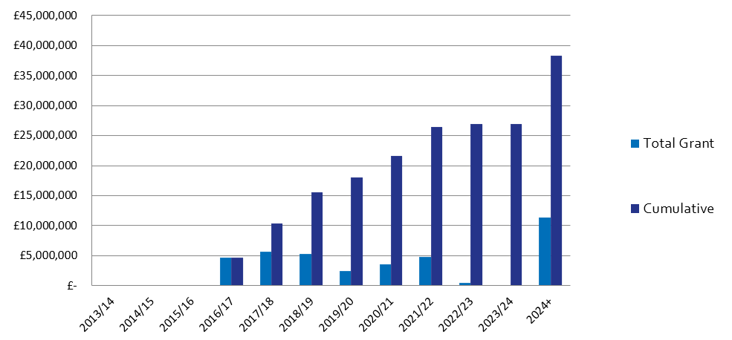
 |  |  |  |  | Q1 | Q2 | Q3 | Q4 |  | In Year Actual
 |  |  |  | Grant | £0 | £0 | £0 | £0 |  | £0
 |  |  |  | Loan | £0 | £0 | £0 | £0 |  | £0
 |  |  |  | Housing Completions | 3 | 0 | 0 | 0 |  | 3
Planning Consents |  | Starts on Site |  | Housing Completions |  |  |  |  | Grant Payments
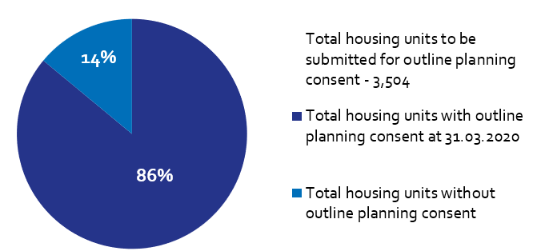 |  | 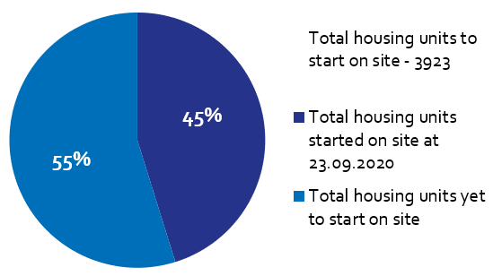 |  | 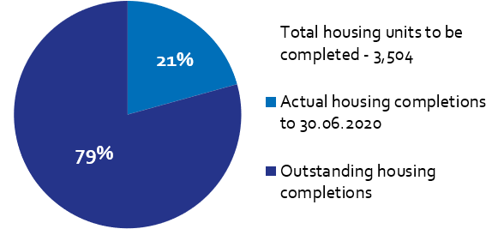 |  |  |  |  | 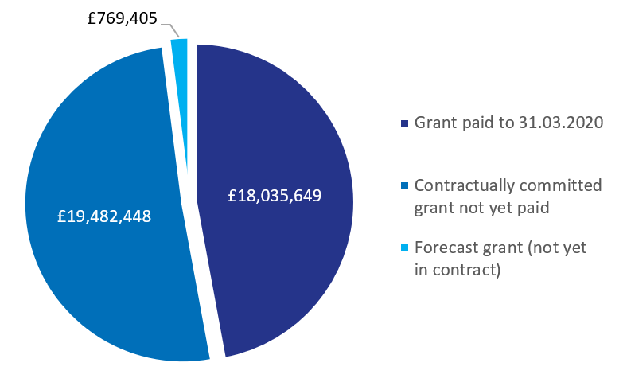
Of the Homes England residential City Deal sites, only Pickering’s Farm is yet to achieve planning consent.  An outline application was submitted last financial year, with determination scheduled Q2 2020. |  | Housing starts have been claimed for 1,773 units on Homes England City Deal sites to date, out of a total 3,923 units (including Walton Park Link and Cottam Brickworks). |  | There have been 725 housing completions to-date across Homes England City Deal sites.  There were 3 housing completions during this reporting period. |  |  |  |  | To date, £18,035,649 has been paid to LCC as grant, with a further £19.4m contractually committed across Homes England City Deal sites.

